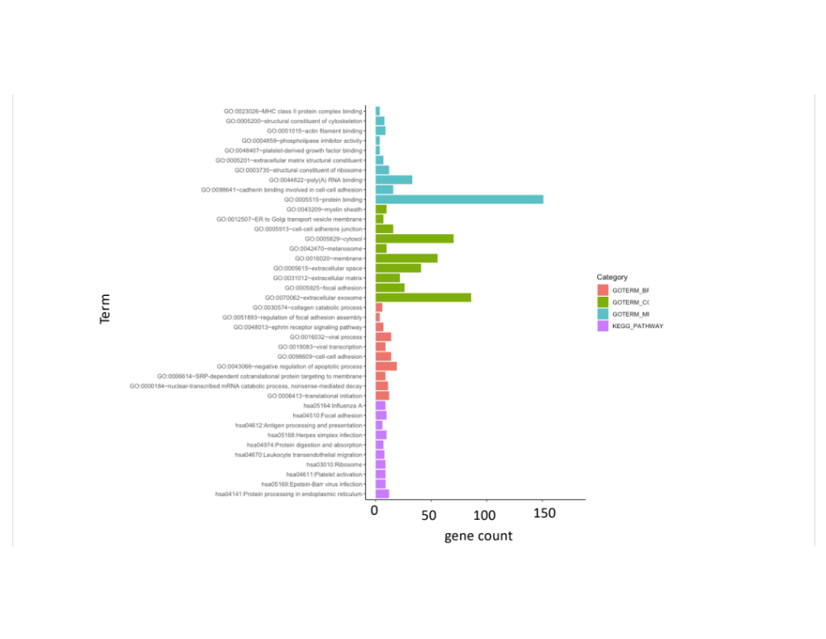
Figure 4

Figure 4. A bar plot of the DEGs the 30 top GO annotations regarding biological processes (BP), cellular component (CC), molecular function (MF) is shown by colors of red, green, and blue respectively. The top 10 KEGG pathway enrichments of the DEGs is shown by the purple bars. The bars on the x-axis represented gene counts.

